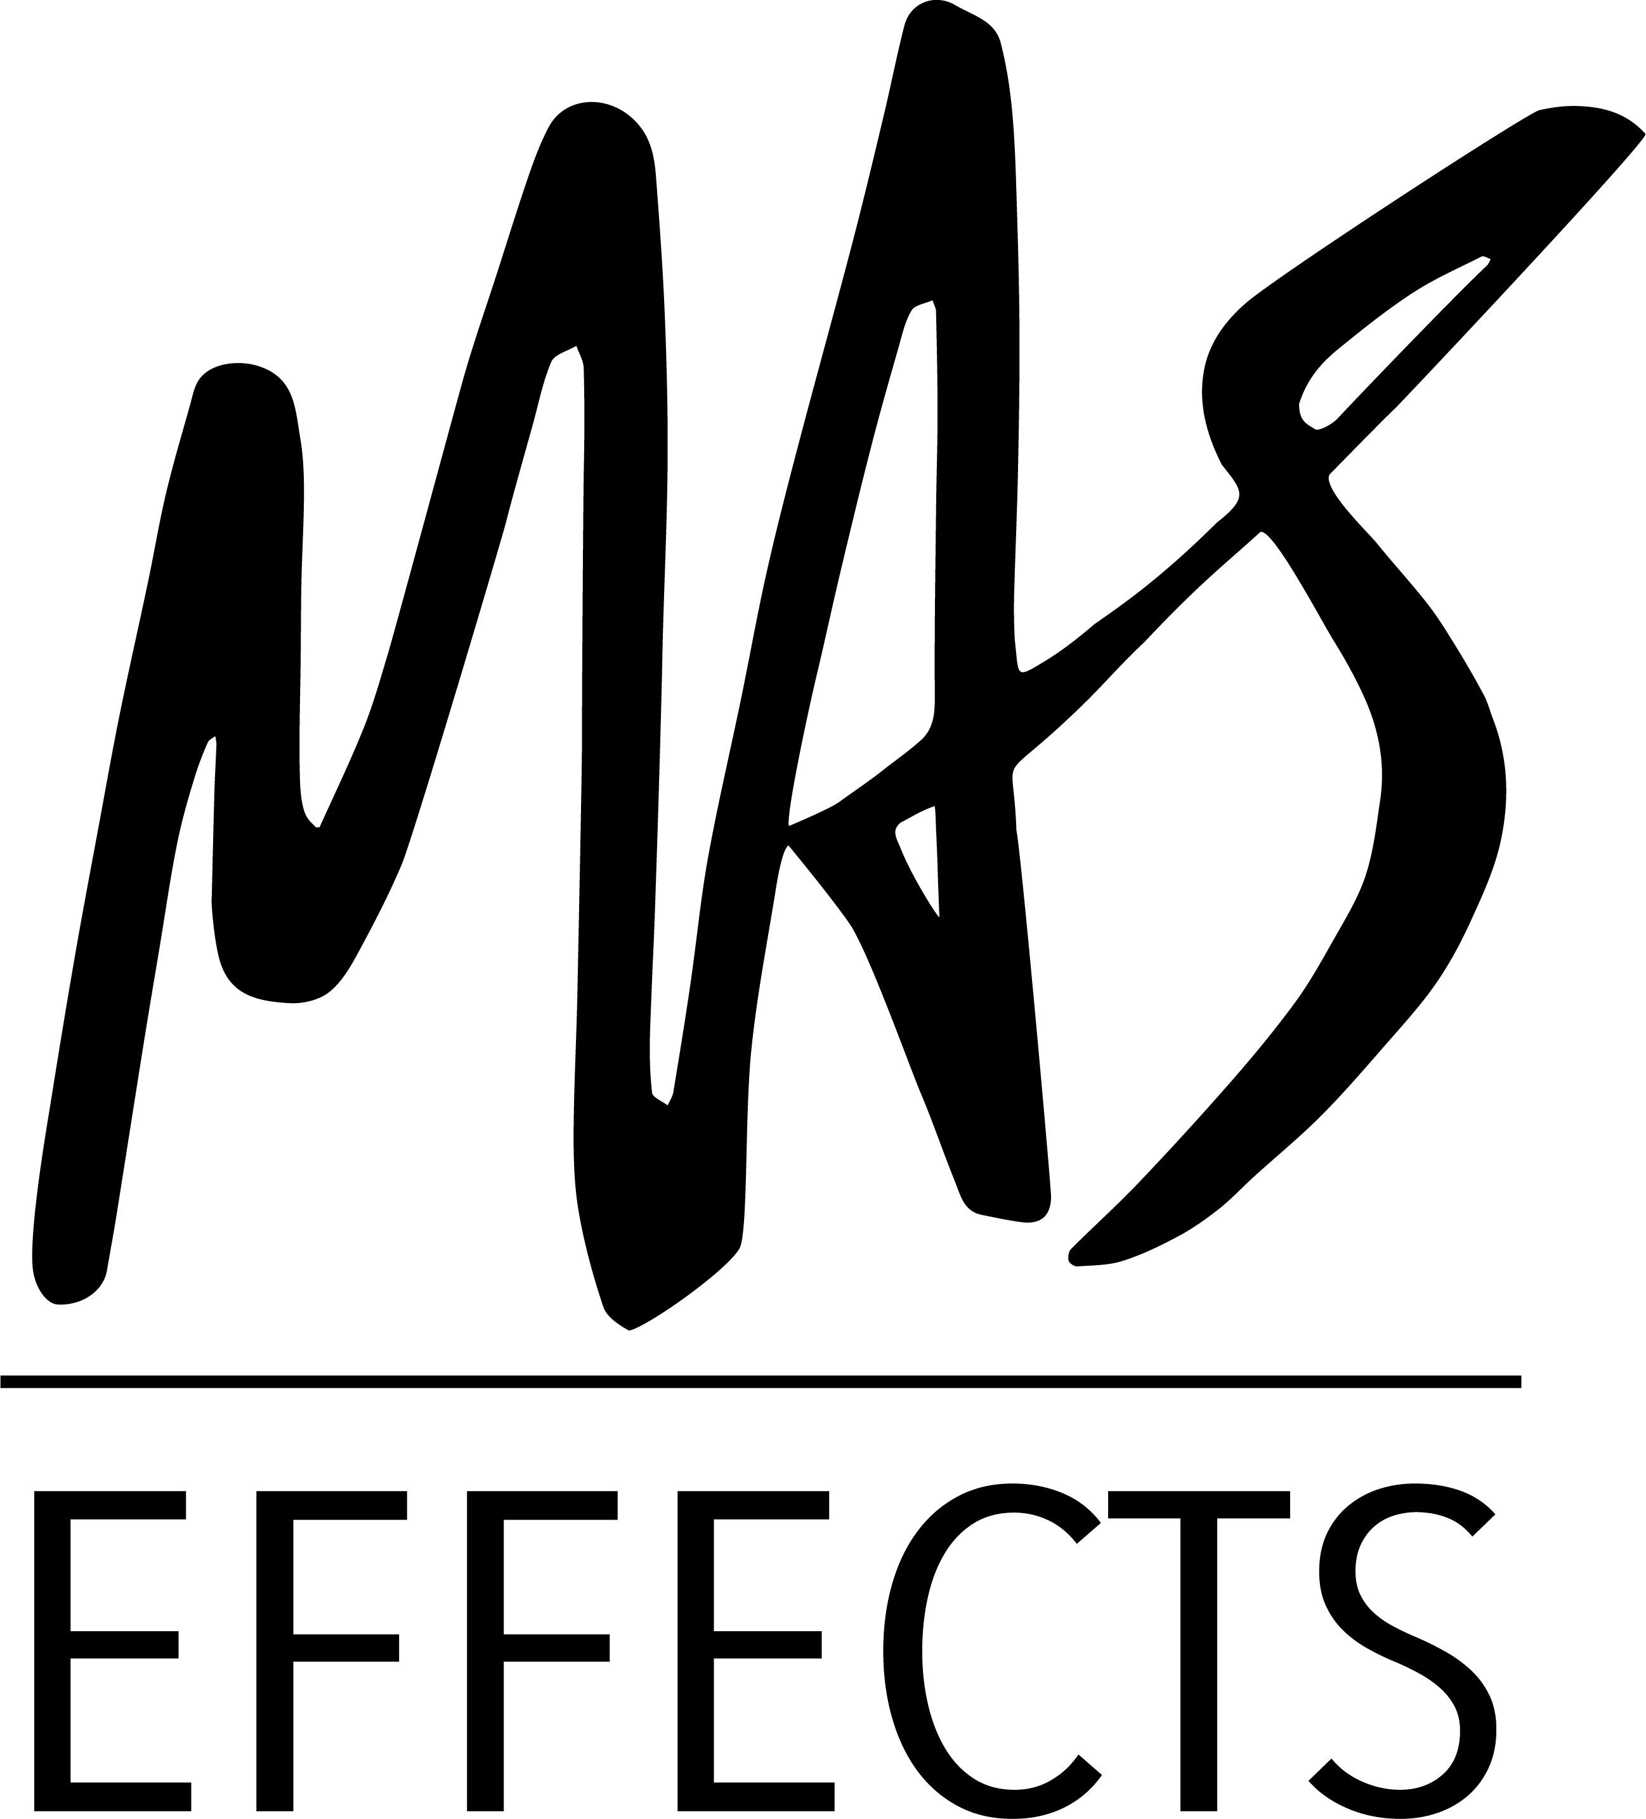

FOR IMMEDIATE RELEASE
MAS Effects
mas-effects.com

Mark A. Stratman
mark@mas-effects.com
(312) 493-3760

MAS Effects Introduces Sona Fuzz
Extremely High Gain Tone Queen

Lockport, IL - November 23, 2021 - Sona Fuzz is the latest addition to the MAS Effects lineup, bringing guitar and bass players incredible tonal control and extremely high gain fuzz in a gorgeous package.

See a demo video here: https://www.youtube.com/watch?v=DZPqqRPHv90

Additional demos are available on the Sona Fuzz product page: mas-effects.com/sona

Highlights of the Sona Fuzz include:
  - 3 different powder coats available: the standard Natural finish, as well as special limited Sparkle and Sunshine finishes
  - "Body" switch adjusts the input filter
  - "Tone" knob pans between high pass and low pass filters on the output
  - Unique 4 transistor, silicon, extremely high gain fuzz is designed for simple biasing and predictable, stable behavior
  - Soft touch, relay controlled, true-bypass foot switch also allows for hold to momentarily engage or bypass

Sona Fuzz is available in select retailers or directly online at mas-effects.com for $149, and includes free shipping within the US.

About MAS Effects: MAS Effects has been making fun and unique guitar pedals and DIY parts since 2020. Feeling that the world doesn't need yet another company doing endless reissues of the same handful of circuits, Mark A. Stratman founded MAS Effects in Lockport, IL to focus on unmet niche needs, fun and quirky novelties, and opportunities to leverage his digital expertise for amazing new effects and DIY utilities. Popular offerings have included a multi-patch DSP platform pedal, Christmas tree ornament "pedal" kits, budget hand-built "Illustrator Series" fuzzes, DIY relay bypass kits, and an expression/volume slider.

