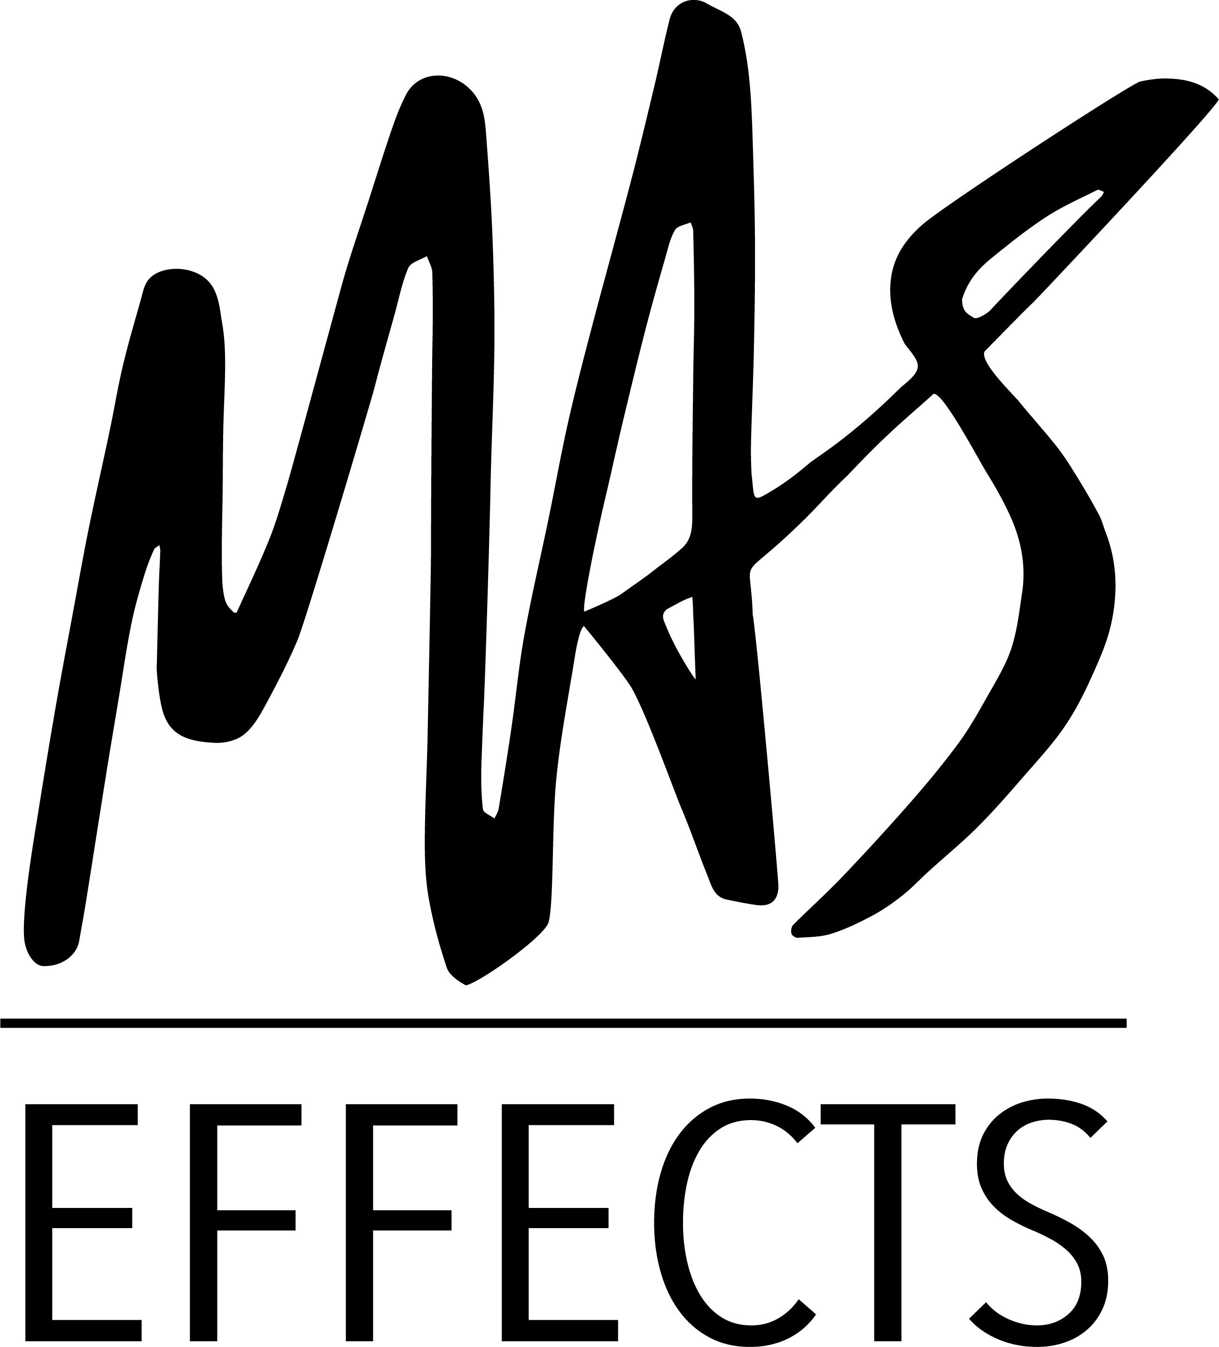

HOLD UNTIL MAY 31

MAS Effects
mas-effects.com

Mark A. Stratman
mark@mas-effects.com
(312) 493-3760

MAS Effects Releases The Expanse, a Harmonic Tremolo With Vast Ambience
You can keep it on Earth as a standalone tremolo, or toggle the ambience to get lost in space
Lockport, IL - May 31, 2022 - MAS Effects' latest and most exciting pedal has released, bringing players a delightful and versatile harmonic tremolo that can traverse the spectrum from practical to far-out. It can serve as a subtle always-on effect, or an extremely prominent and wavy filter, or a shoe-gazing centerpiece for exploration, and everything in between. It features expression jacks and the basic controls you'd expect from a tremolo, as well as a switchable layered reverb, freeze effects, and textured delay with several options to control feedback.
The Expanse is a genuine labor of love that went from a personal passion project, through a ridiculous number of iterations, and several rounds of beta testing by pedal enthusiasts, demo artists, and professional musicians who generously poured themselves and their hearts and expertise into it as well. The result is a pedal that can serve as both a basic daily driver tremolo, as well as a unique and complimentary blend of sounds that bring inspiration and fun.
The Expanse is available now for $229 at the MAS Effects site: https://mas-effects.com/expanse
Demo videos, as well as more pictures and info are available at the MAS Effects site: https://mas-effects.com/expanse

About MAS Effects: MAS Effects has been making fun and unique guitar pedals and DIY parts since 2020. Feeling that the world doesn't need yet another company doing endless reissues of the same handful of circuits, Mark A. Stratman founded MAS Effects in Lockport, IL to focus on unmet niche needs, fun and quirky novelties, and opportunities to leverage his digital expertise for amazing new effects and DIY utilities. Popular offerings have included a multi-patch DSP platform pedal, Christmas tree ornament "pedal" kits, budget hand-built "Illustrator Series" fuzzes, DIY relay bypass kits, and an expression/volume slider.

